Installing the Deep Map app on Android

**Step 1.** Open the app-release.apk file from the email on your phone.

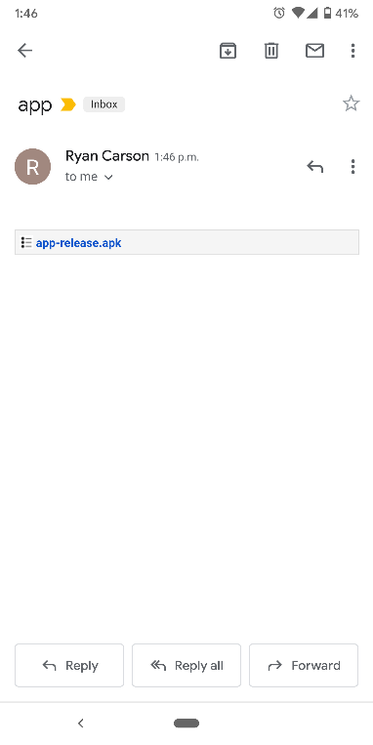

**Step 2.** Allow the app to load.

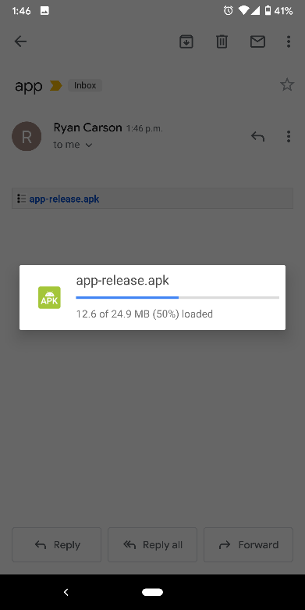

**Step 3 (if prompted).** Choose the Package Installer.

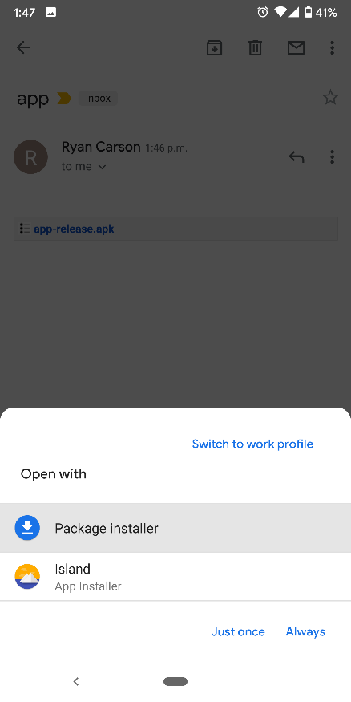

**Step 4.** Select **Install**.

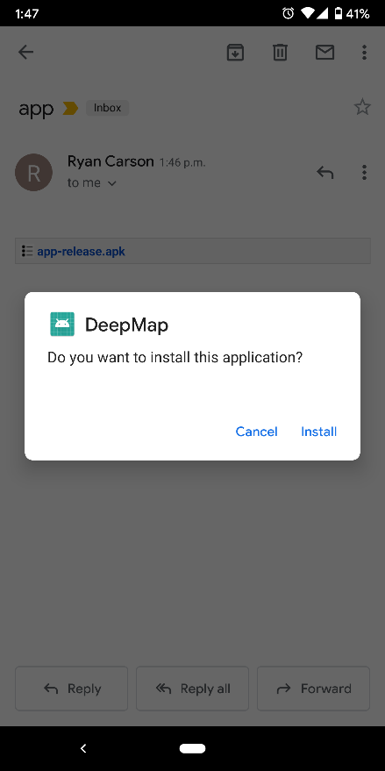

**Step 5.** Select **INSTALL ANYWAY**.

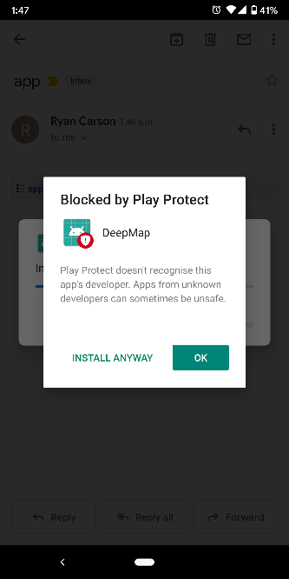

**Note**: You may be asked to enable your email program to allow you to install APK files. If so, follow these steps:

**Step 1.** Select **Apps and notifications.**

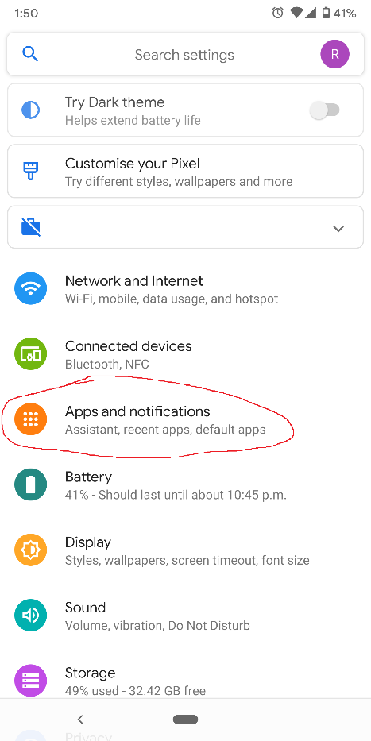

**Step 2.** Select **Advanced**.

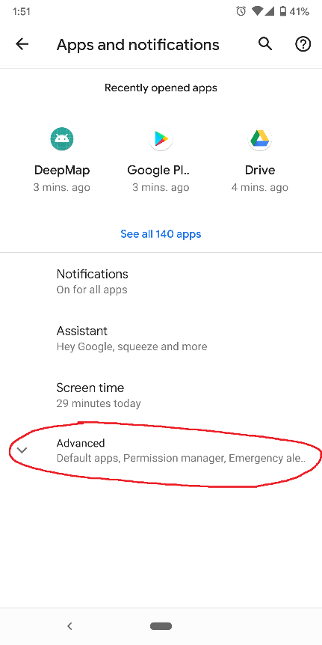

**Step 3.** Select **Special app access**.

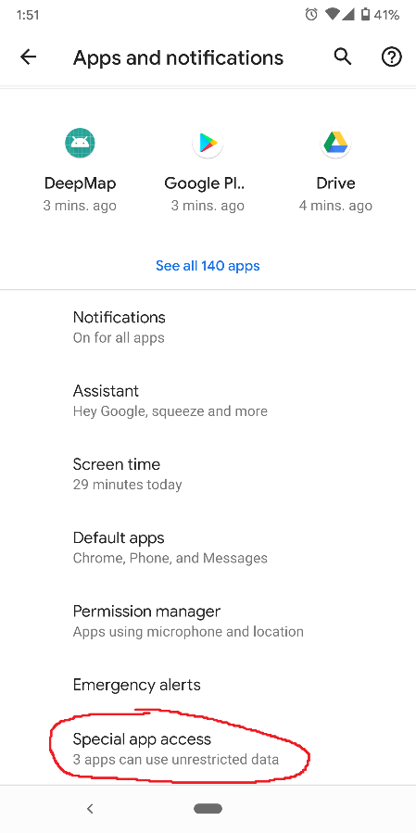

**Step 4.** Select **Install unknown apps.**

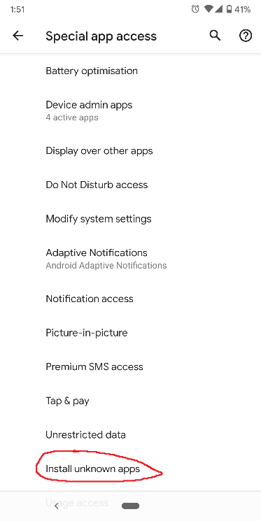

**Step 5.** Select your email app you are trying to open the file on (eg. Gmail).

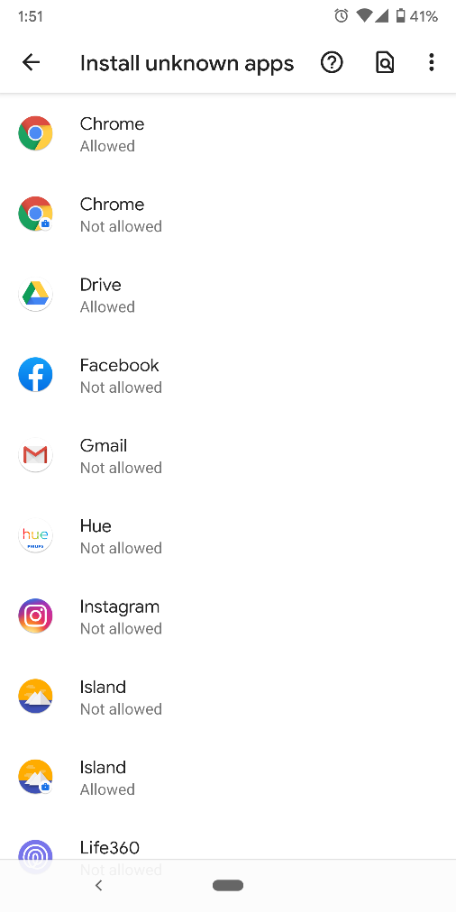

**Step 6.** Select the option **Allow from this source**.

